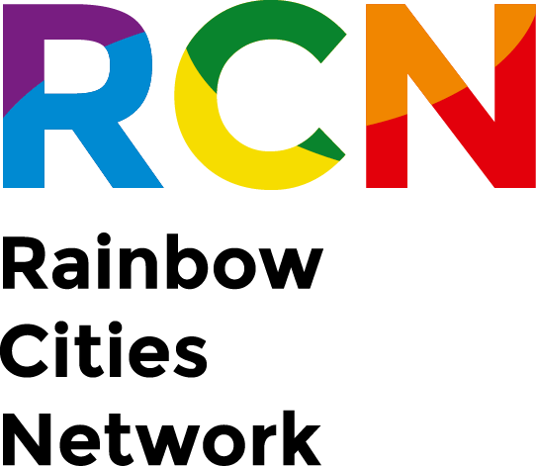

SOLIDARITY REDUCTION FORM
Date
City´s name
City´s address
Number of inhabitants:
Member since:

To Rainbow Cities Network´s Board

I am writing this Solidarity Reduction letter to request that (City´s name) fee be reduced (in 20%, 30%, 40%, etc.) in light of...
Reasons:

Sincerely,

(Sender´s Name and position, same as the person who signed the MoU)

